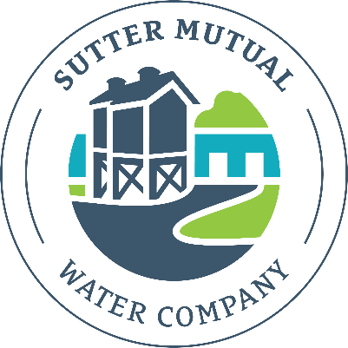
SUTTER MUTUAL WATER COMPANY
P.O. BOX 128
ROBBINS, CALIFORNIA 95676
(530) 738-4423/FAX (530) 738-4327

ANNUAL MEETING OF SHAREHOLDERS
Monday, April 1, 2024 - 10:00 a.m.
Robbins Community Hall

FINAL AGENDA
General Session

- Welcome and Call to Order
- Roll Call of the Board of Directors and Introductions
- Approval of the Agenda
- Comments from the Shareholders
- Audit Report – 2022 Handout
- Report on Healthy Rivers and Landscapes – Northern California Water Association – David Guy
- Report on Important Water Legislation – Northern California Water Association – Ivy Brittain
- Report on Biological Opinion/Long Term Operations – Thad Bettner – Sacramento River Settlement Contractors
- Review Water Supply Situation and Related Water Operations for 2024 – MBK Engineers – Anne Williams/Marc VanCamp
- Review Cropping Situation and Related Water Operations for 2023/2024 – BIDA – Jon Scott/Roger Cornwell
- Report on State and Federal Regulatory Compliance Programs and Issues (water measurement, water management plan, water rights reporting) - Jon Scott
- Discussion on Sutter Basin Infrastructure and Project Updates – Roger Cornwell
- Election of the Board of Directors
- Other Matters of Interest to Shareholders
- Adjourn

******************************************************************************
Directly following the General Session, the Board of Directors will meet to organize and conduct Company Business including the following: Shareholders interested in attending this meeting are welcome.

- Call to Order and Roll Call
- Election of Board Officers and Appointment of Management
- Review Crop Map and Plan Water Operations for 2024
- Approve Operations Budget and Set Water Rate for 2024
- Set Electrical Conductivity Level for Recaptured (Booster) Water
- Miscellaneous Other Business
- Adjourn

